Diagrams - Multi-Sport Analytics & Prediction Platform
1. High-Level System Architecture
This diagram illustrates the complete technology stack and component interactions with improved clarity on data flow and fallback mechanisms.
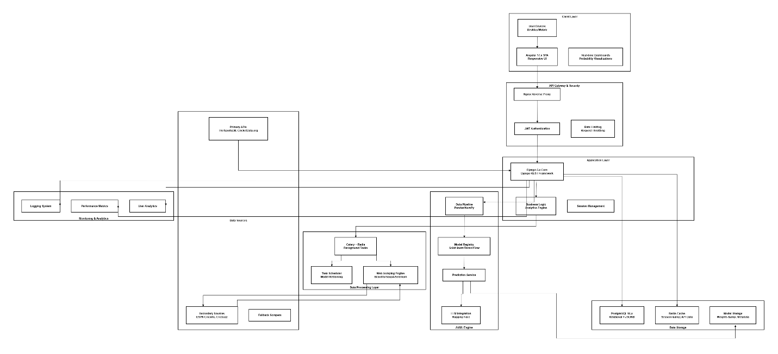

2. End-to-End Application Workflow
Detailed flowchart of the 8-step process with decision points and parallel processing.
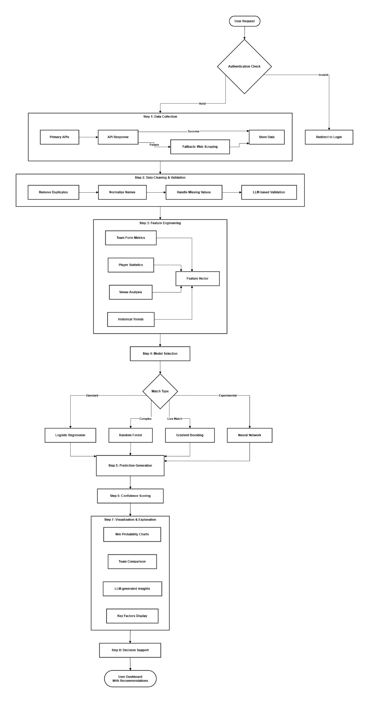

3. Hybrid Data Collection Strategy with Fallback
Detailed flow highlighting the intelligent switching mechanism between data sources.
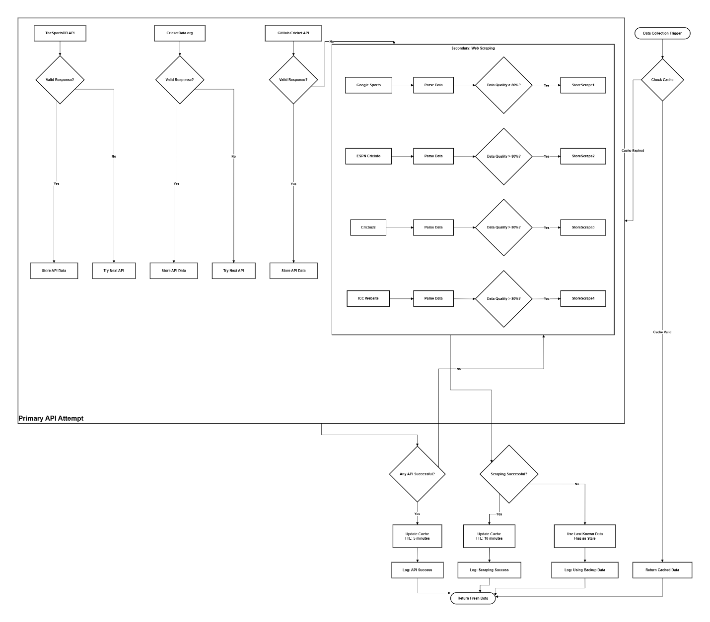

4. Enhanced AI/ML Prediction Process
Detailed diagram showing the complete ML pipeline with multiple model types and explainability.
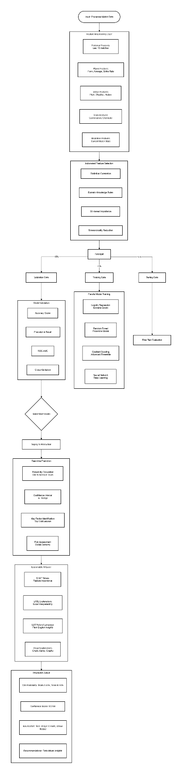
5. User Management & Security Architecture
Added diagram showing authentication, authorization, and user role management.
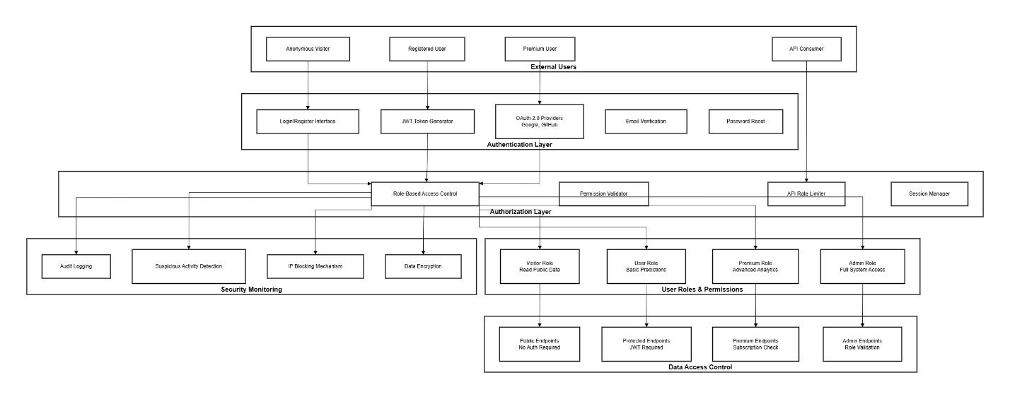

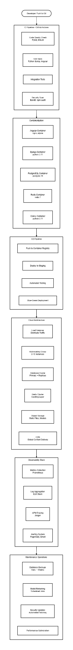
6.Deployment & DevOps Pipeline
Added diagram showing CI/CD, containerization, and cloud architecture.

7.Data Flow & ETL Process
Added diagram showing complete data pipeline from collection to consumption.
